

**Speech Emotion Recognition**

Instructor: Dr. Rony Darazi

**Presented by:**

* Elie Youssef
* Charbel Nahhas

**Objective:**

Determine an approximation of the speaker’s emotion as well as the gender, the age, and the race

**Technical Challenges:**

* Not perfectly recorded audio(done with available equipment) and noise in sounds
* Limited samples of different phrases and contexts in database
* Inability to determine accurately the exact emotion, age, gender… due to many factors that can’t be controlled

**Proposed Method:**

Comparing the input signal with the signals in the database to find the most 3 correlated signals with the same features as the input signal to predict as much as possible the emotion, the age, the gender, and the race.

**Block Diagram**

Entropy

Sampling

Input Speech signal

Emotion Recognition

This is a sample text. Insert your desired text here.

Normalization

Signal cross correlation

Comparison with database

Speech signal’s features Extraction

Speech rate

MFCC

Energy

Pitch

**Main Process**

**Step 1**

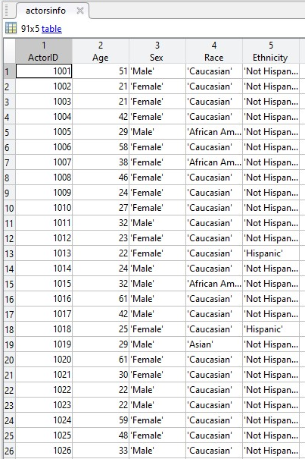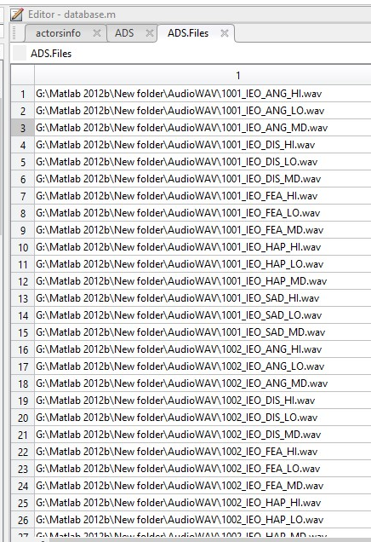We specified the input audio file that we want to determine the emotion from and created an audio database containing all the audios in the database as well as the actors’ information(gender, age…)

**Step 2**

We computed the cross correlation between the input audio and all the audios in the database to find the best audio that matches the input signal.

**PS**: - For better efficiency we took in consideration 3 signals.

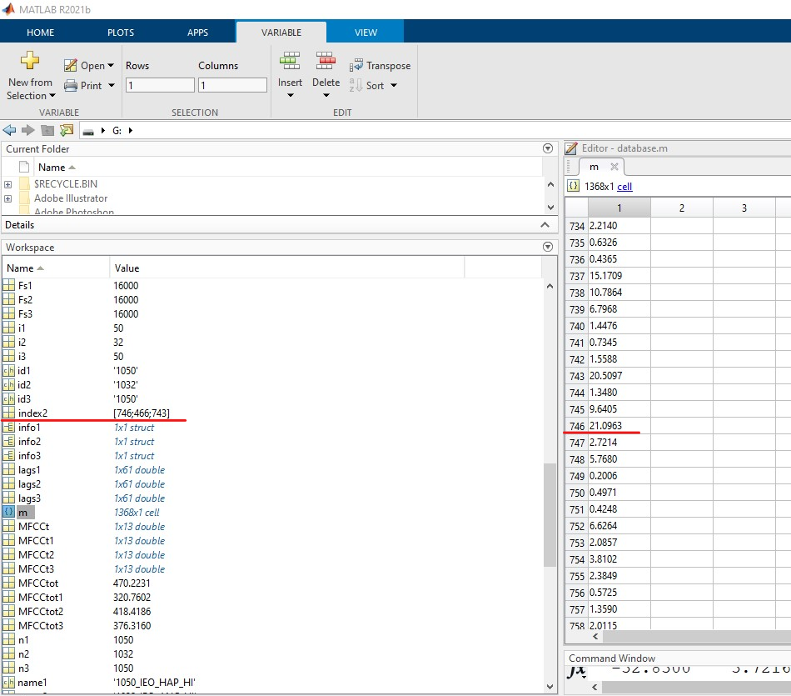

*In the figure above are shown the cross-correlation coefficients and in the index2 variable, the indexes of the 3 biggest correlation coefficients.*

**Step 3**

We computed the different factors of each signal(cross-correlation,pitch,entropy…) to identify the similarities of these audios

1. 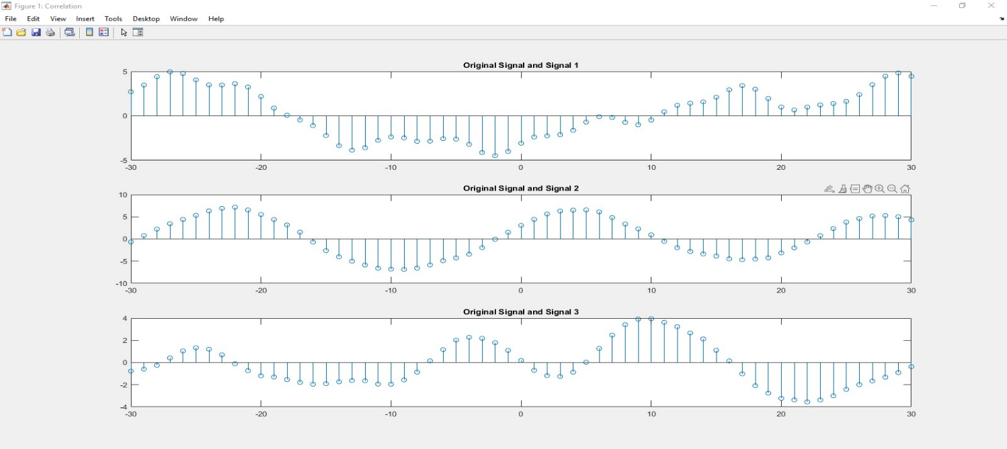**Cross Correlation**:

*We can clearly see that the second signal has the better correlation relationship of all the signals with the input signal. Therefore, strengthening our choice of taking 3 signals to compare instead of one.*

1. 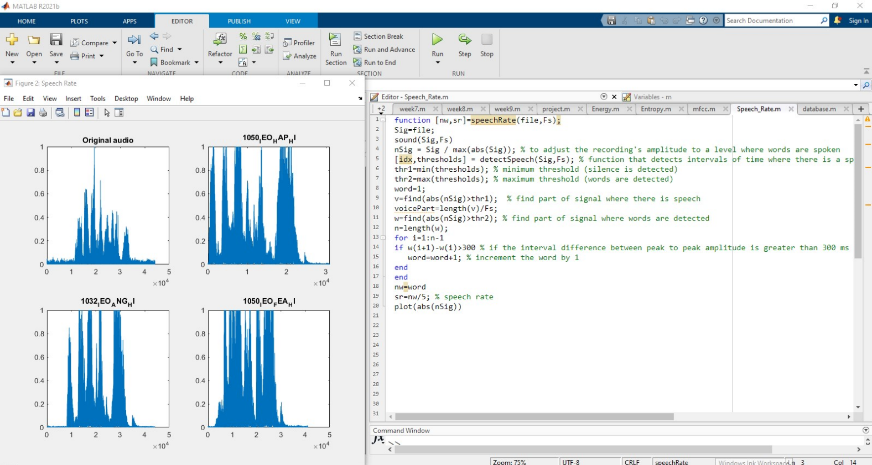 **Speech Rate**

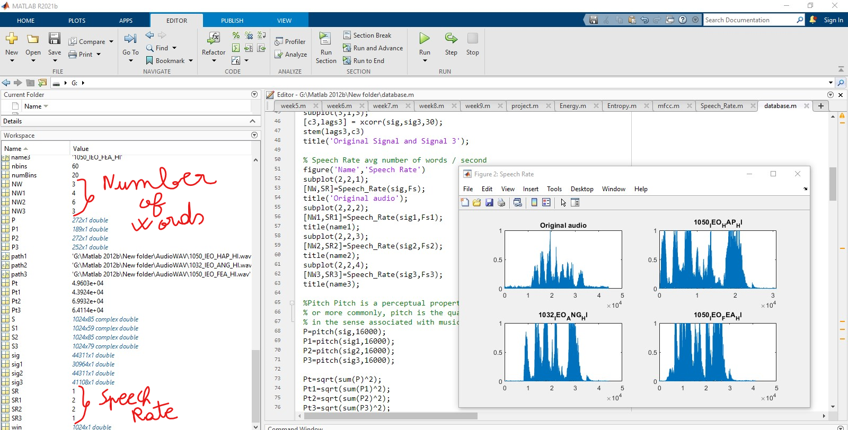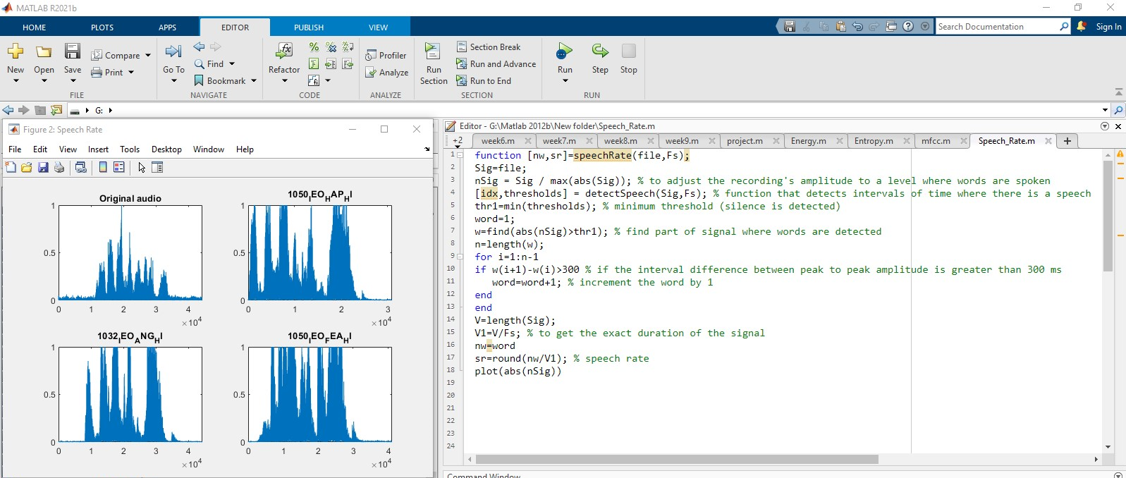

*The number of words differ from a sample to another and the ability of the program to detect a complete word based on the tonality of the speaker, the pronunciation of the word and the silence interval of time between one word and the other also differ.*

1. **Pitch**

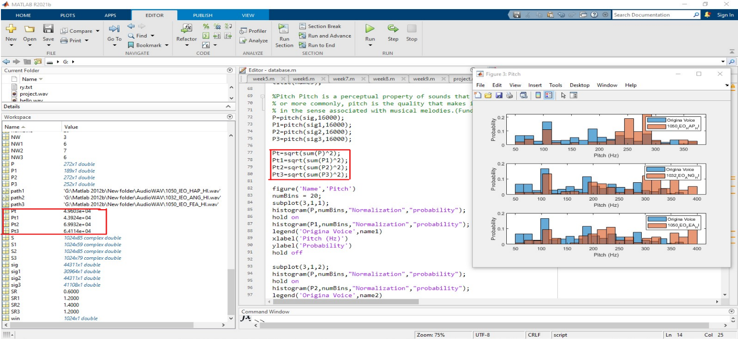The function Pitch is a predefined function in MATLAB which takes as arguments the signal to study the pitch from and its frequency.

We first computed the pitch of each signal and then computed the mean value to see which value (Pt1,Pt2 or Pt3) is the nearest to the value of the input audio (Pt)

From the values in the workspace, the third signal has the value the nearest to the input value, the figure 1 strengthen this result as we can see the distribution of the frequencies in the histogram in the third case matches the best the original signal.

1. **MFCC (Mel Frequency cepstrum coefficients)**

*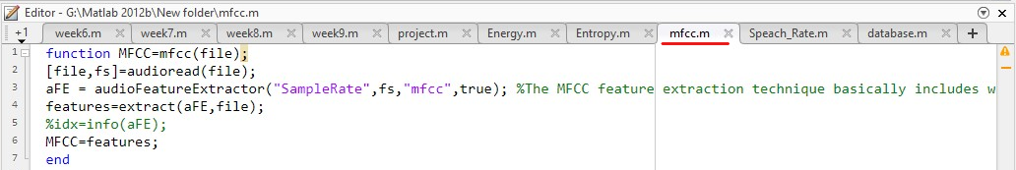The MFCC feature extraction technique basically includes windowing the signal, applying the DFT, taking the log of the magnitude, and then warping the frequencies on a Mel scale, followed by applying the inverse DCT. Mel-frequency cepstral coefficients are coefficients that collectively make up an MFC.*

The audioFeatureExtractor is a predefined MATLAB function to extract specific features from the input audio( like in this case we extracted the mfcc).

*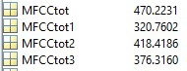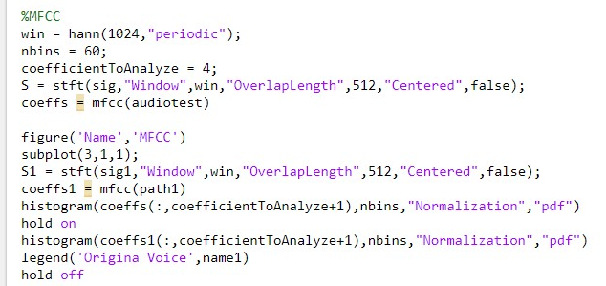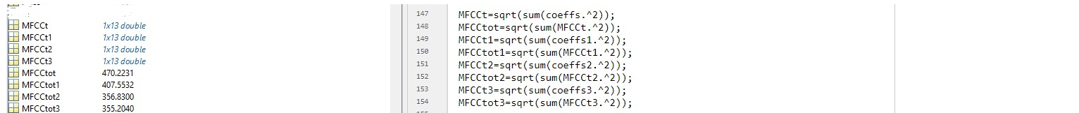A first approach was to extract the coefficients of the Mel-frequency for each signal and plot their histogram in comparison with the original signal*. *Then we computed the average coefficient value of these signal (MFCCtot1,2,3) and compared them with the coefficient of the original signal. As we can see the second signal’s value is the nearest to the original signal.*

*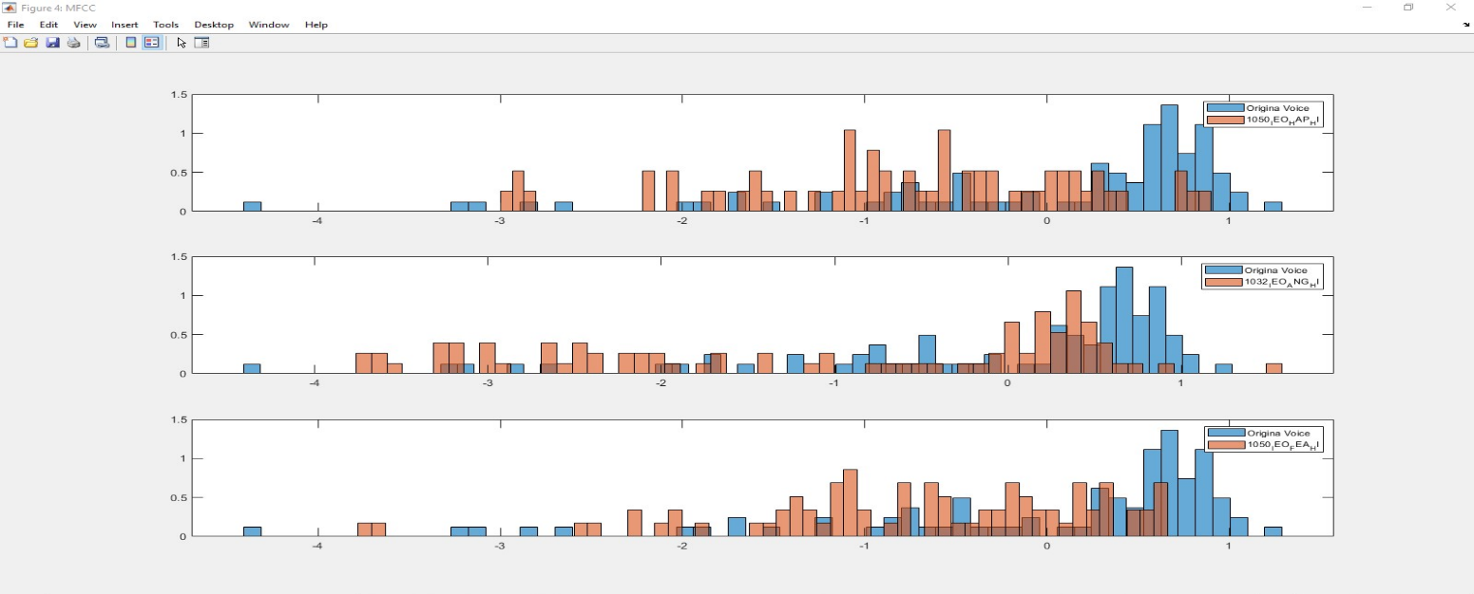As seen in the figure below, the second histogram uniform distribution matches the best the original signal frequencies distribution meaning the result is correct.*

1. **Entropy**

*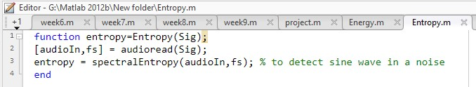The spectral entropy is a measurement of its spectral power distribution*

*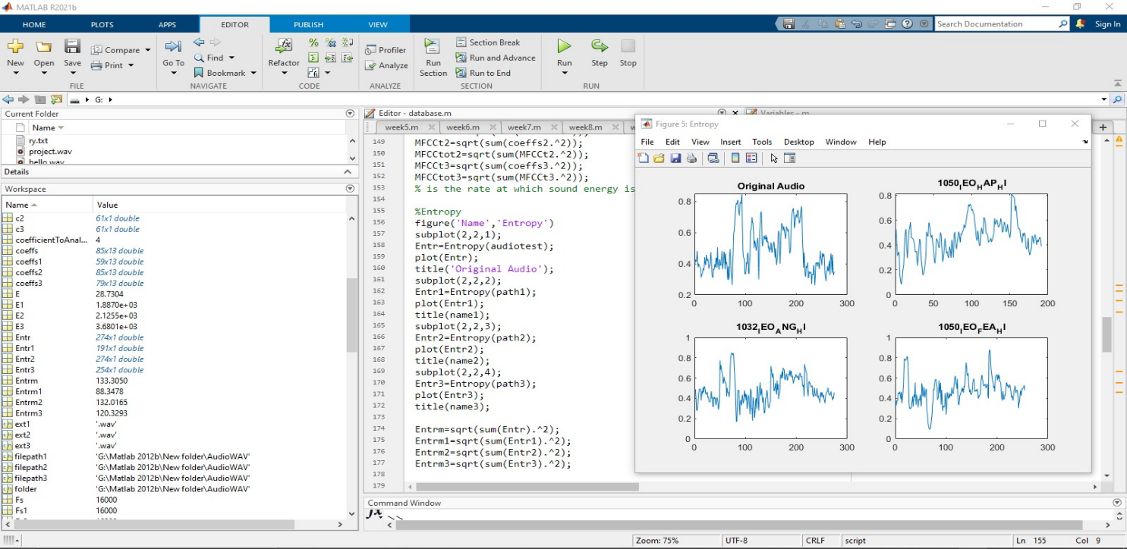The spectralEntropy is a predefined MATLAB function to extract the sine wave of the signal.*

*We compared the entropy’s mean of each signal (Entrm1,Entrm2 and Entrm3) to the entropy’s mean of the original signal. As shown in the workspace, the nearest value to the original signal is the one of the second signal. In addition, the sin wave of the 2nd signal has approximatively the same behavior around the middle value (0.4) as the original signal.*

1. **Energy**

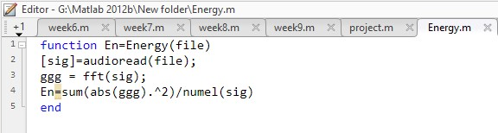It is the rate at which sound energy is emitted, reflected, transmitted, or received, per time unit.

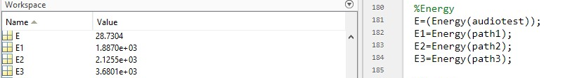We computed the fft of the signal to calculate the energy of the signal.

As we can see the nearest energy value to the original energy value is the 2nd signal

**Results**

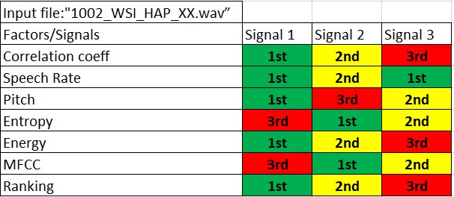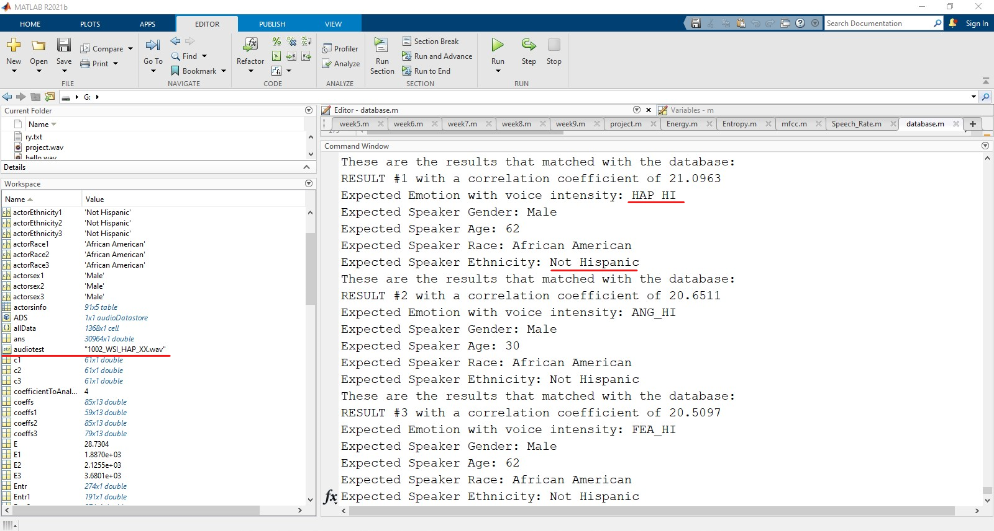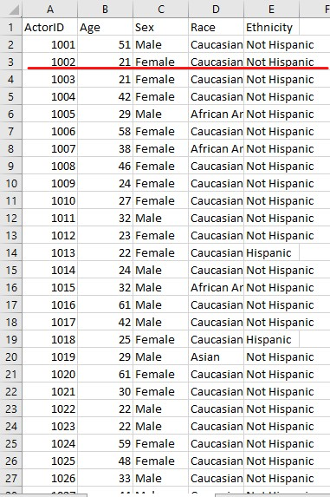For the input audio “1002_WSI_HAP_XX.wav” which is an audio where the speaker says happily “Will stop in a couple of minutes”. Below is the information of the speaker with ID=1002,the ranking of each sample based on the values previously computed and the results of our program

**Interpretation**

The program guessed the emotion and the ethnicity of the speaker right in the second result. But failed to guess the tonality, the gender, the age, and the race of that same speaker.

While for the other results, it was not quite accurate.

**Possible Improvements for better Results**

* Use of better equipment to reduce noise effect
* Use of a better dataset with more flexibility

**Thank You**